AC Grid Output and input of AC/DC Rectifier1 Result:

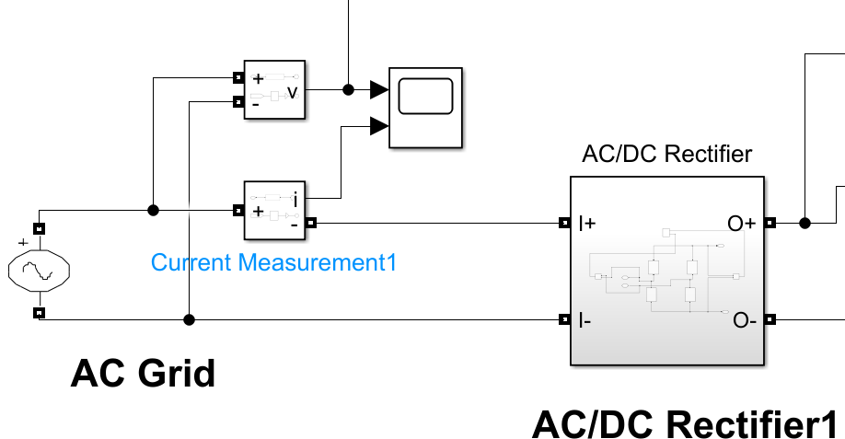 ISKA Result hai yeh:

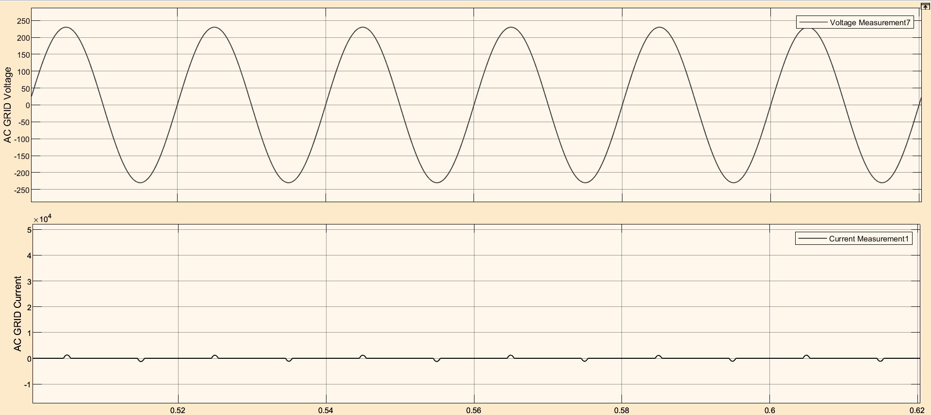

Or

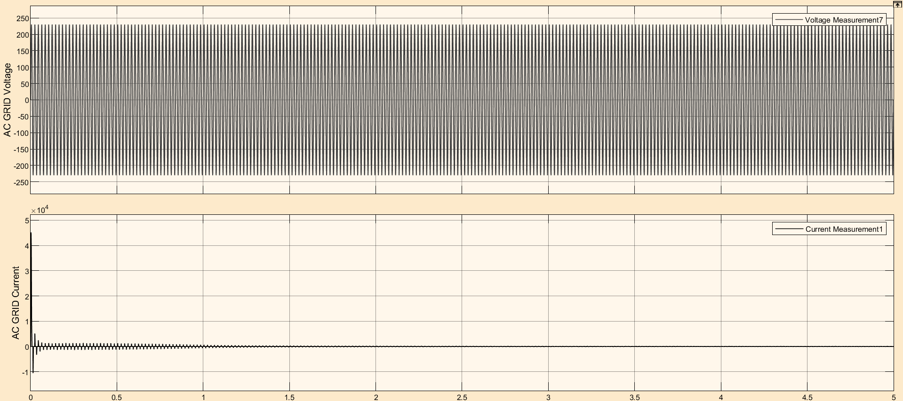

Output of AC/DC Rectifier1 and Input of HFI DC/AC Inverter1:

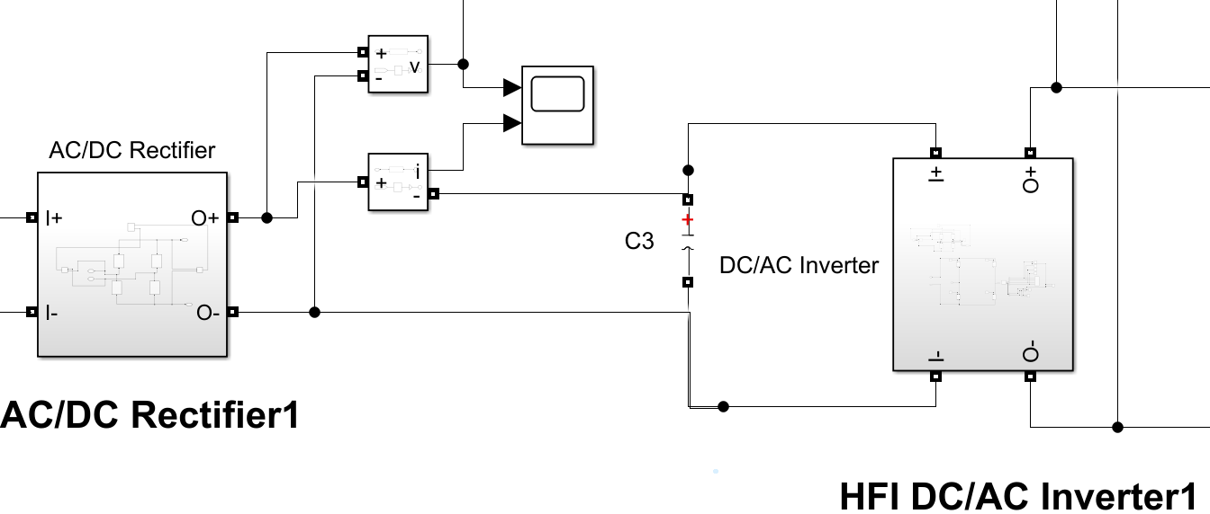 ISKA RESULT HAI YEH

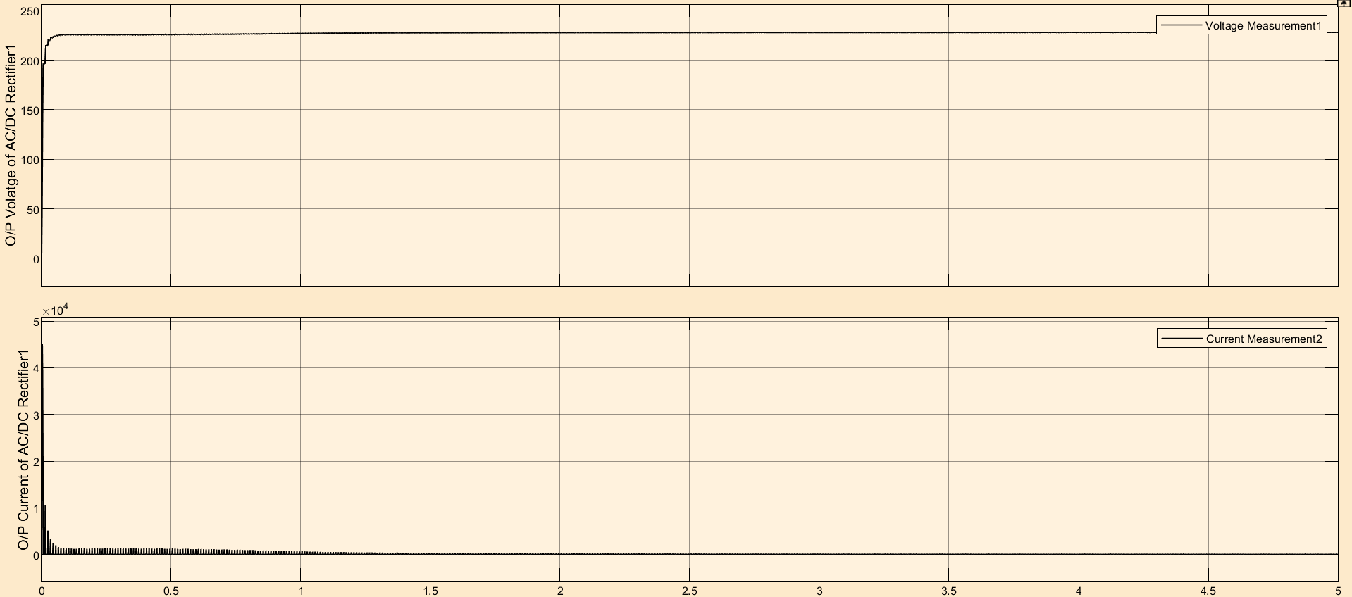

Output of HFI DC/AC Inverter1 and Input of Primary Coil Result:

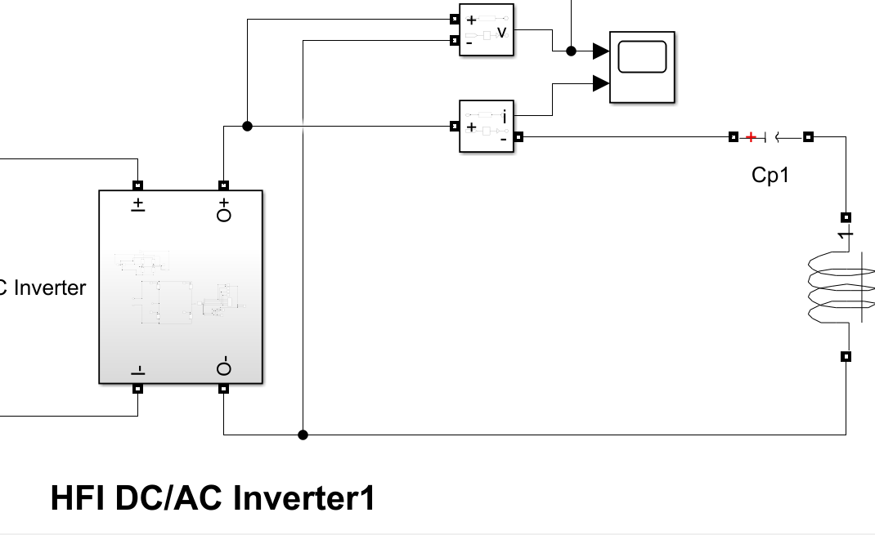 ISKA Result hai yeh

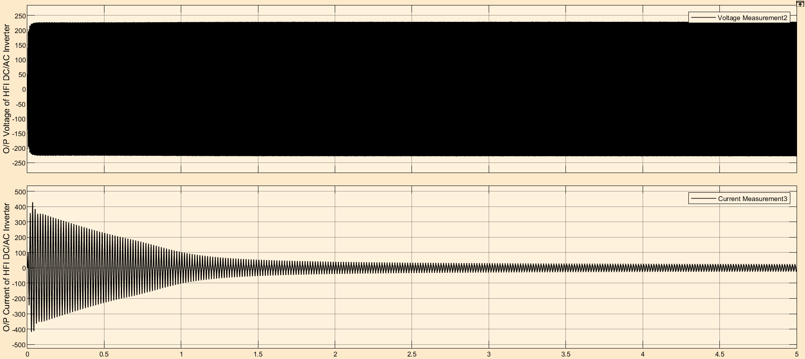

or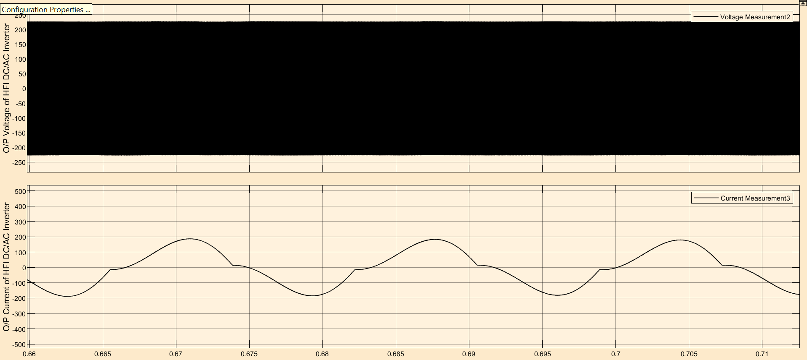or

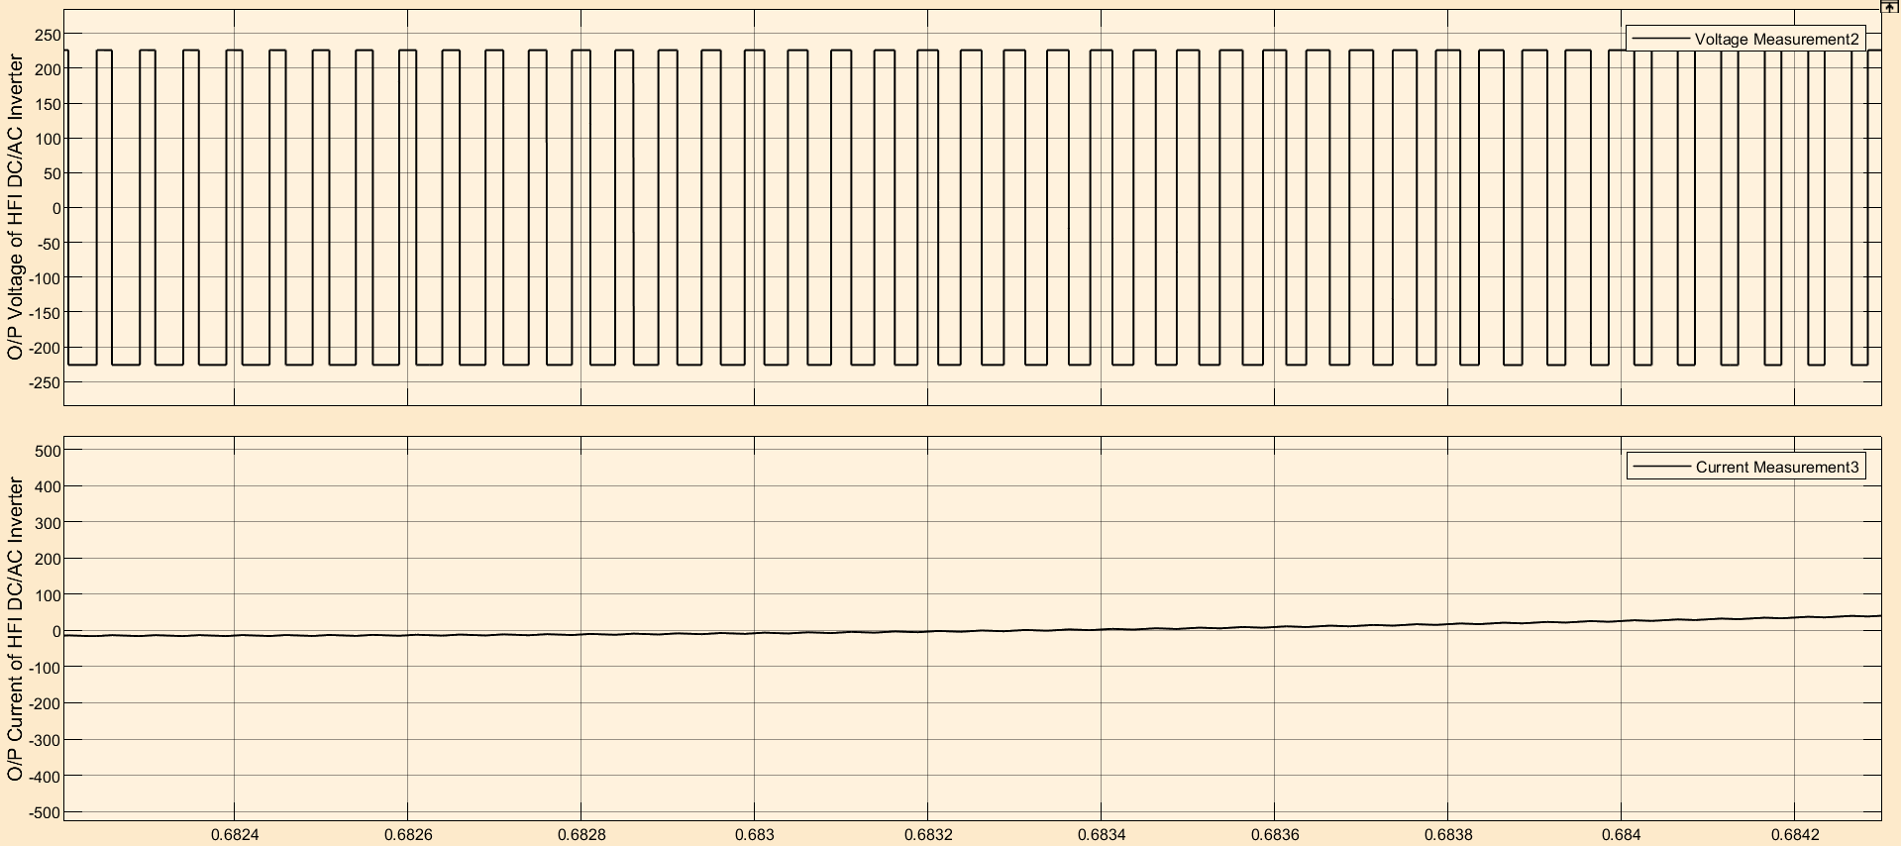

Output of Secondary Coil and Input of AC/DC Recitifier2 Results:

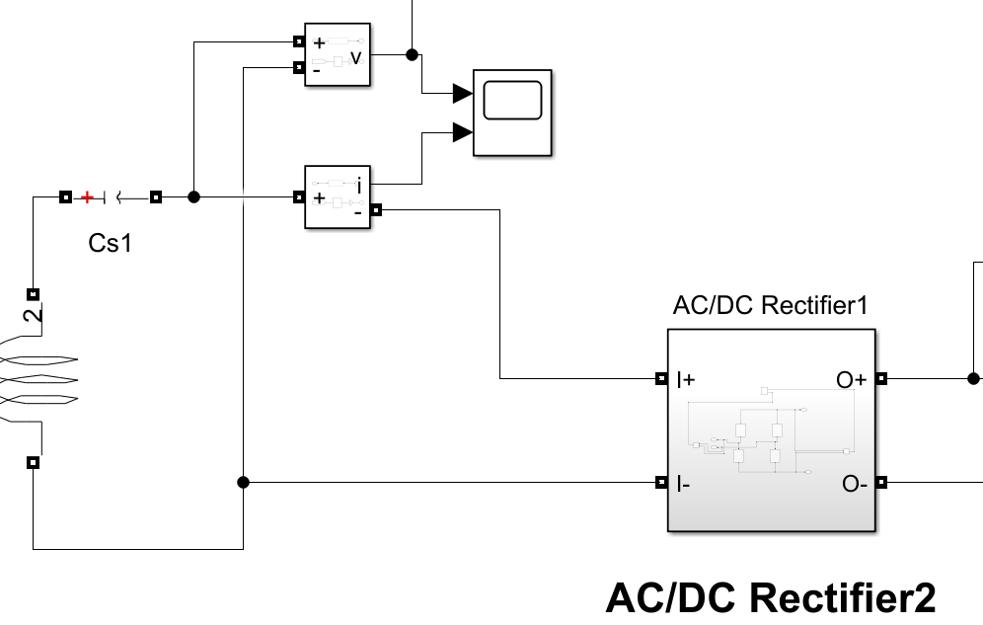 ISKA RESULT HAI YEH

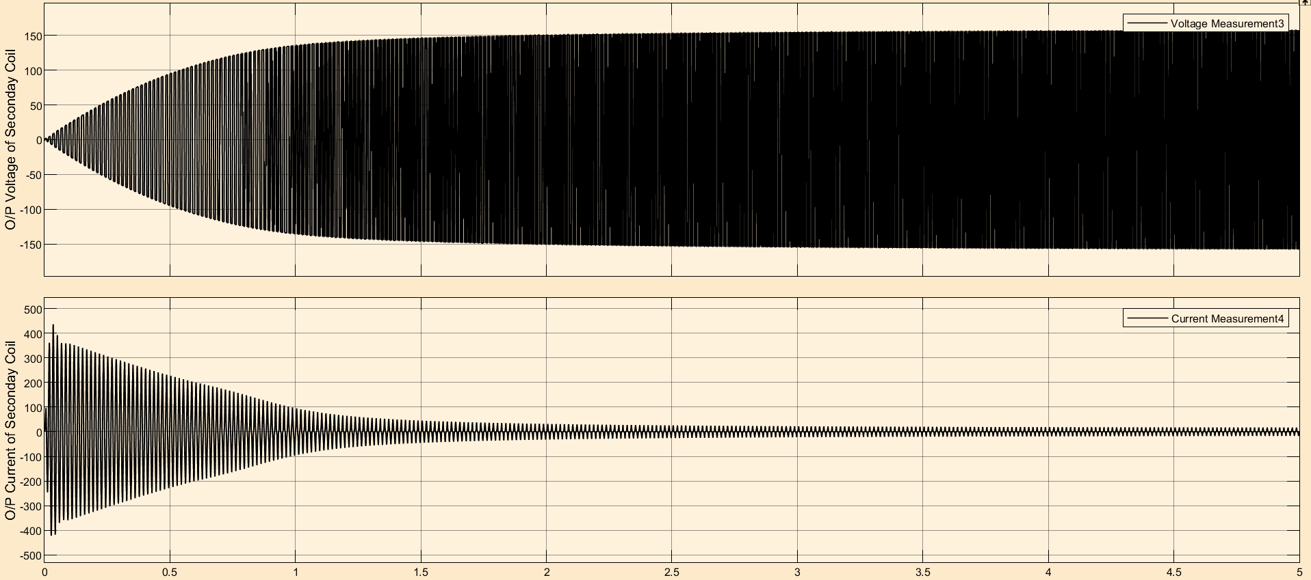

OUTPUT of AC/DC Rectifier2 and input of DC/DC Converter: 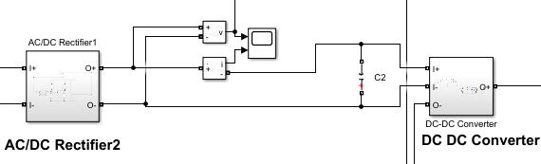 ISKA Result hai yeh

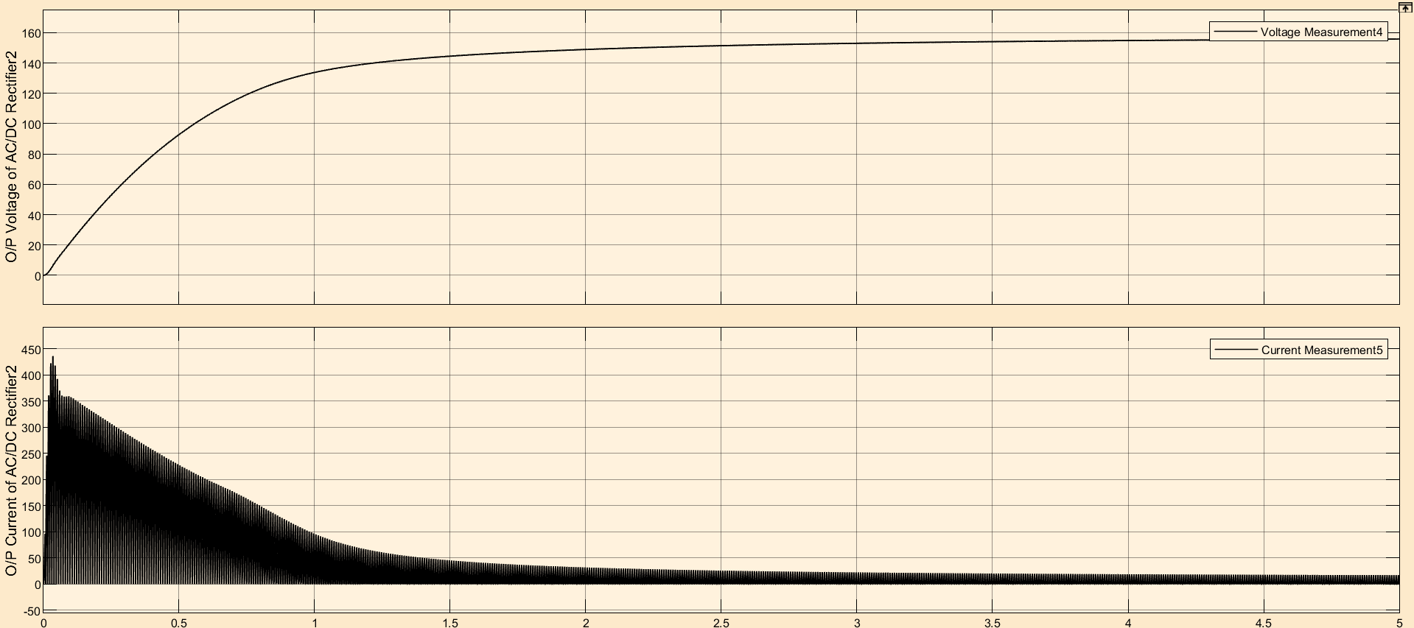

Output of DC/DC Converter with Load Connected of 100 ohm

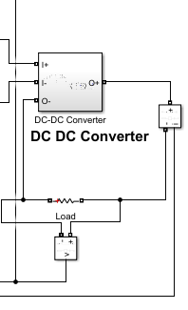 ISKA RESULT HAI YEH

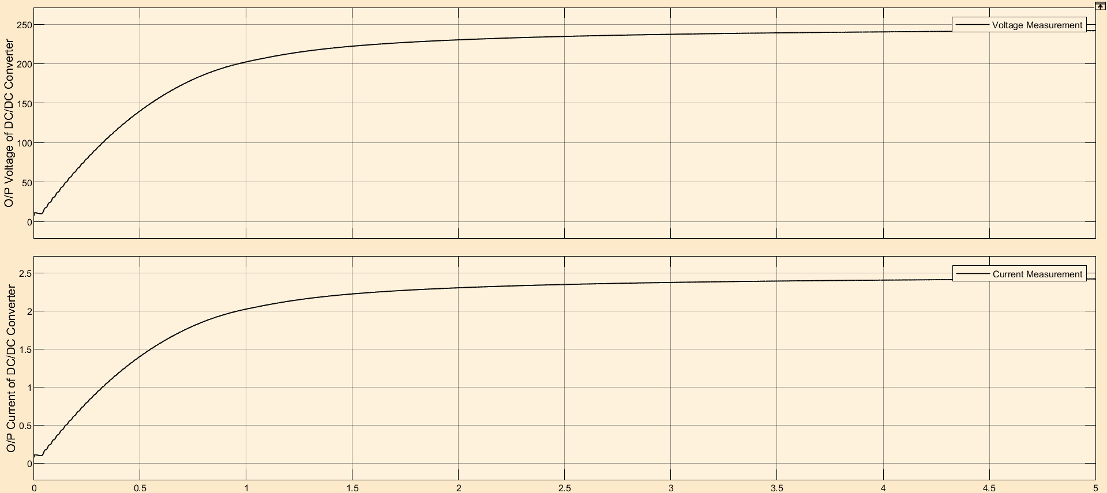

Output Power:

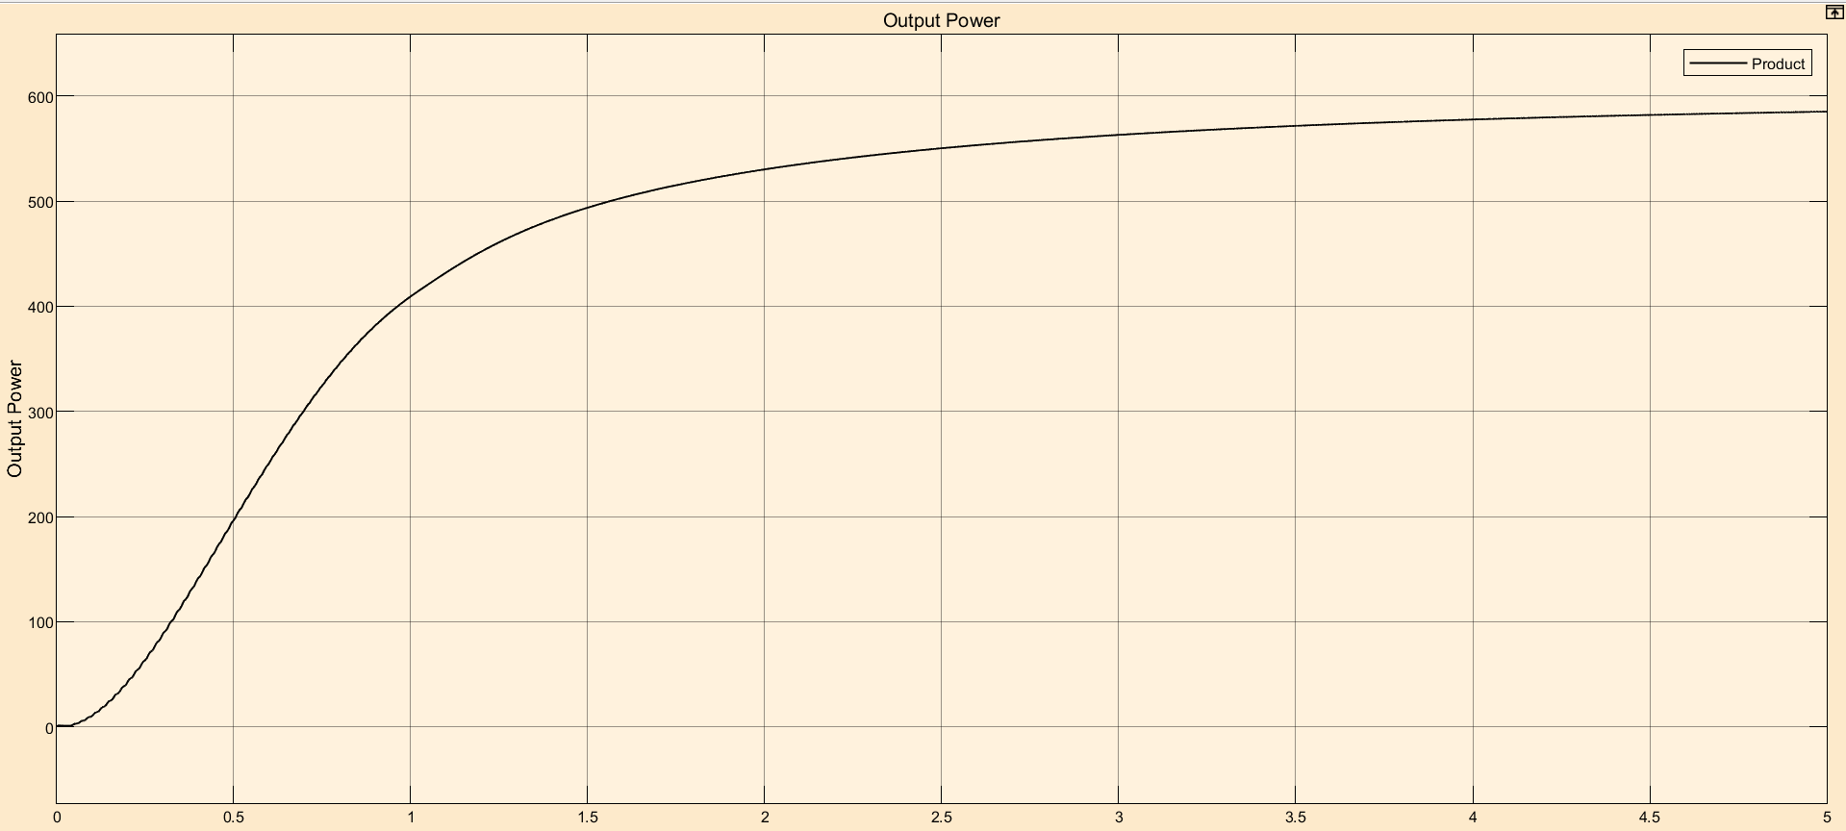

ALL Voltage Waveform together from start to end

